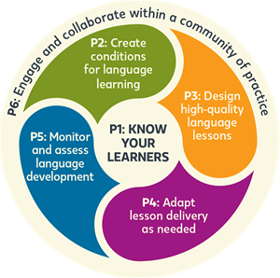

KNOW YOUR LEARNERS
Teachers learn basic information about their students’ families, languages, cultures, and educational backgrounds to engage them in class and prepare and deliver lessons more effectively.

Some Practices for Principle 1
Teachers gain information about their learners.
Teachers collect information about their students’ linguistic and educational backgrounds to determine correct placement for students. They also seek to learn a new student’s cultural and geographic background as a resource for classroom learning .
Teachers embrace and leverage the resources that learners bring to the classroom to enhance learning.
Teachers tap their learners’ prior knowledge purposefully in their teaching. They try to determine what gifts and talents students bring to the classroom, what interests motivate them, what life experiences they have had that are curriculum-related, and what else in their backgrounds has influenced their personalities and beliefs.

Classroom Activities That Support Principle 1
Ready to get to know your learners? Try these activities from books in the popular New Ways Series from TESOL Press!
Click the images below to view the full activity.
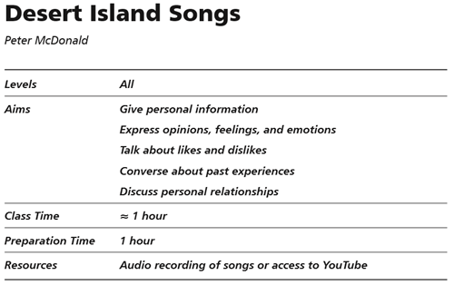
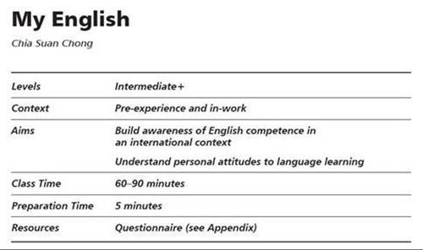
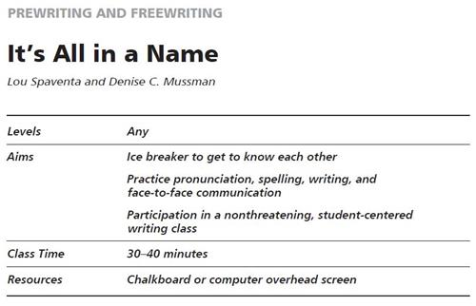
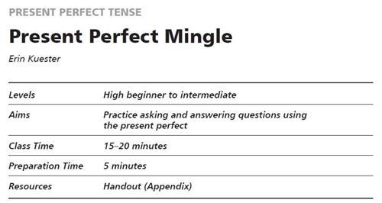
Try these activities from the TESOL Resource Center (TRC).
Click on the images below to view the full activity.
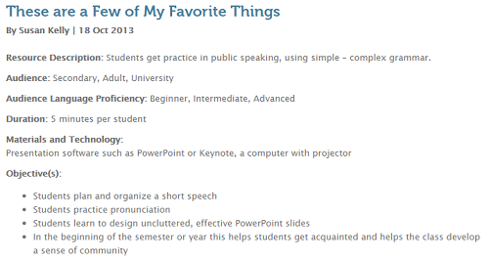

Beyond the classroom, teachers address ​Principle 1 in other ways.
Teachers of English learners know that many of our students come to school with social, emotional, and financial issues that are beyond those that are part of a child’s typical experience or development. English learners may have left a war-torn country or experienced violence or extreme poverty. Some have been victims of religious persecution or witnessed a relative being arrested or killed. Others have arrived in the United States to live with a parent or relative whom they hardly know.

In the following vignette, a teacher explains one student’s social and emotional needs:
Mario, age 16, left Honduras in a hurry, taking his little sister with him. He had stopped going to school after third grade because gangs were kidnapping students and threatening to kill them if they didn’t join. But the situation had recently gotten worse, and Mario feared for his sister’s life and his own. He and his sister crossed the U.S. border in Texas, and after three months in a detention center, they ended up living with their brother, whom they had not seen for many years and hardly knew. Mario and his sister now go to school. Mario’s classes are very hard for him; his sister is doing a little better. After school, Mario rushes off to his dishwashing job to earn money that he and his sister can live on. He wants to stay in school and graduate, but he is only in ninth grade and is having trouble trying to work long hours and pass his subjects in school.
Even if English learners have arrived in the United States with an intact family or were born in this country, they may experience a clash of cultures if their American friends live by one set of rules, but their immigrant parents insist on a different set. These circumstances can cause turmoil in children and adolescents as they grow up, and they may need counseling services to work through these issues. Teachers of English learners can advocate for appropriate counseling services to be available, both in the school setting and outside school, and in the student’s home language, if needed. Teachers can stay informed about developments around the country and the world that can affect the educational, social, and emotional well-being of English learners.

Other educators at a school, district, or program should also get to know their English learners.
For example, if you are a curriculum director, you have a very important role to play in ensuring that all curricula that are adopted by your district are truly accessible by English learners of all proficiency levels and supports their educational success. The following are some of the actions that you can within a culture of shared responsibility for English learners in your district.
Supporting Principle 1. Know Your Learners
- Make sure that knowledge about teaching linguistically and culturally diverse students is evident in all district curricula. Ensure that students of all proficiency levels can access district curricula, because these will suggest materials and strategies explicitly designed for English learners of varied proficiency levels—beginners to advanced.​
- Look closely at the curricula taught in the district to make sure that they are appropriate for English learners, not only by affording multiple entry points as suggested above but also by empowering students through the use of themes and materials that connect well with the background knowledge, cultures, and life experiences that English learners bring to the classroom.​
- Work to make sure that mandated curricular materials are readily available in the high- incidence home languages of your district, thus supporting delivery of the curricula in dual language and bilingual education programs, as well as providing readily accessible subject-subject matter materials for students who are literate in their home languages. This will allow students to learn valued content in their home or target language in addition to English.
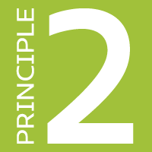 | CREATE CONDITIONS FOR  LANGUAGE LEARNING

Teachers create a classroom culture so students feel comfortable. They make decisions regarding the physical environment, the materials, and the social integration of students to promote language learning.

Some Practices for Principle 2
Teachers demonstrate expectations of success for all learners.
Student achievement is affected by teacher expectations of success. Teachers must hold high expectations and communicate them clearly to all their students—English learners and other classmates, which will motivate them to perform at a high level.
Teachers plan instruction to enhance and support students’ motivation for language learning.
Language learning is difficult and takes a very long time. Learners may not see the benefits of spending time and energy in learning English if the effort does not have an early payoff or it feels outside their own comfort zone. However, we know that motivation is an important condition for language learning, so teachers need to engage their learners and motivate them to work persistently at learning the new language.

Classroom Activities That Support Principle 2
Try this activity from New Ways in Teaching with Humor from TESOL Press!
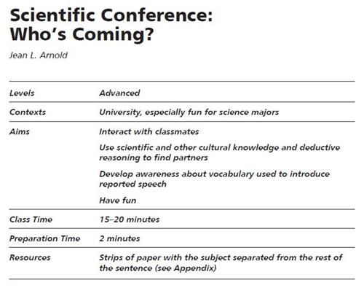
Try these activities from the TESOL Resource Center (TRC).
Click the images below to view the full activity.
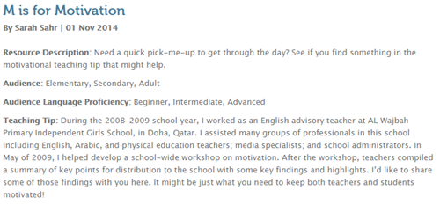
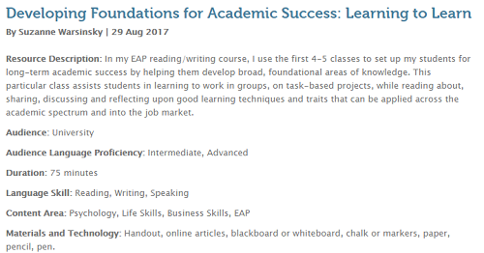

Beyond the classroom, teachers address Principle 2 in other ways
Teachers Support Students' Social and Emotional Needs
- Get to know your school’s families through home visits. You may join in making these visits, or you may encourage teachers or other school personnel to do so. By meeting families away from school, such as in community centers or in their homes, you may have more success in engaging families (Louie & Knuth, 2016).​
- Make sure that all staff members who interact with English learners and their families learn about, acknowledge, and affirm the strengths, capabilities, and contributions made by English learners and their families to your school.
Conduction Home Visits
Excerpt from The 6 Principles for Exemplary Teaching of English Learners®: Grades K-12
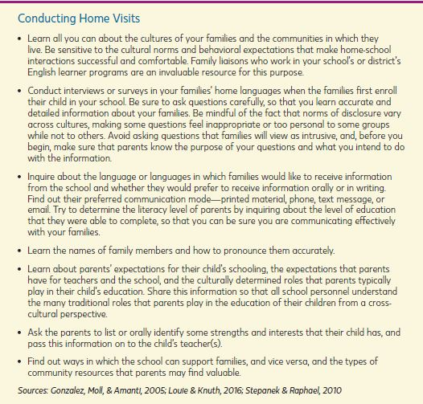
The 6 Principles for Exemplary Teaching of English Learners

Establish a Culture of Shared Responsibility
Special Education Directors and Gifted and Talented Program Directors
- Make sure that all communication to parents is provided in the language they prefer and that only qualified interpreters are present during eligibility and IEP meetings. These steps can empower parents to advocate for their children’s educational needs.​
- Make sure that special educators understand how to shape instruction for students of various proficiency levels and that they know the current proficiency levels of their learners in listening, speaking, reading, and writing. Remember that, by law, dually identified students must receive both ESL and special education services (USED & USDOJ, 2015).

DESIGN HIGH-QUALITY
LESSONS FOR
LANGUAGE DEVELOPMENT

Teachers plan meaningful lessons that promote language learning and help students develop learning strategies and critical thinking skills. These lessons evolve from the learning objectives.

Some Practices for Principle 3
Teachers use comprehensible input to convey information to students.
Comprehensible input is of primary importance for progress in the target language. Whether oral or written, comprehensible input helps English learners understand the meaning of the communication. Teachers scaffold the language input in multiple ways to aid learner perception and promote understanding.
Scaffolding for Comprehensibility
(Excerpt from The 6 Principles for Exemplary Teaching of English Learners®: Grades K-12)
Scaffolding for Comprehensibility | Explanatory Devices for Comprehensibility | Modeling and Demonstrations
- Gesturing and using facial expressions  - Illustrating and using visuals  - Relying on high-frequency vocabulary  - Embedding definitions and explanations  - Providing or asking for L1 translation | - Visual aids  - Audio supports and other multimedia  - Bilingual glossaries  - Picture dictionaries  - Simplified English or home language summaries | - Targeting and modeling the appropriate language register (academic language vs. social language; word choice)  - Providing demonstrations of language in use (e.g., model student essays, sample completed projects)
Teachers communicate clear instructions to carry out the learning task.
Teachers use and teach consistent classroom management practices and routines throughout the school year in an effort to help students understand what is expected of them in a classroom and throughout a lesson. Teachers use simple directions with patterned language that they repeat each time.

The 6 Principles ​writing ​​team ​member Linda New Levine ​on Principle 3

Classroom Activities That Support Principle 3
Try these activities from books in the popular New Ways Series from TESOL Press!

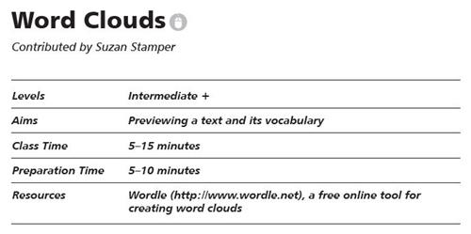
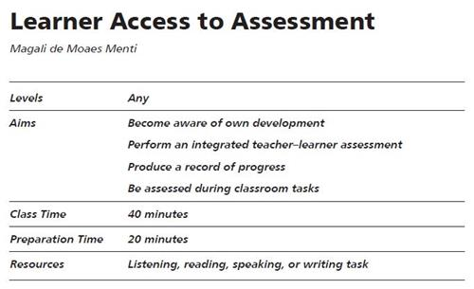
Try these activities from the TESOL Resource Center (TRC).
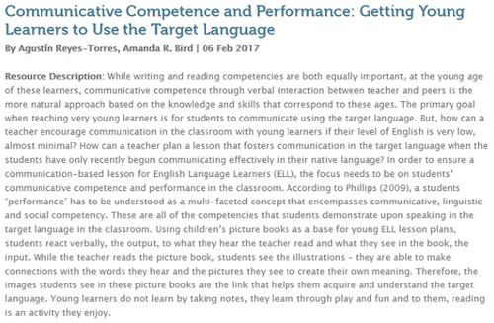
Teaching Tip: Co-Teaching in the EFL Classroom with Cooperative Learning

Beyond the classroom, teachers address Principle 3 in other ways
Develop and Review Curricula, Materials, and Assessments
- Teachers of English learners can help to improve curricula, materials, and assessments in several ways. At the state level, they can serve on curriculum development committees, helping to develop or revise English language frameworks or standards. They may participate in state-level efforts to infuse language development and English learner–appropriate teaching techniques into grade-level and content-area frameworks​
- Teachers of English learners may also design or review district formative and summative assessments or create rubrics for measuring student progress, taking into consideration the different English proficiency levels that students exhibit.

Establish a Culture of Shared Responsibility
School Principals and Assistant Princip​als
To fully embrace your position as educational leader of your school, read all the chapters in The 6 Principles for Exemplary Teaching of English Learners so that you are well versed in what constitutes a high-quality instructional program for English learners.
Colleagues
Show your colleagues strategies and techniques that integrate content and language instruction and allow English learners at all levels of English proficiency to have access to and participate in grade-level, standards-based instruction.
Reading Specialists and Instructional Coaches
- Adopt research-based approaches to the teaching of reading and writing in a second language, and make sure that these approaches are in use in all instruction settings in which English learners participate.​
- Promote professional learning at your school related to the effective education of English learners, focusing on teaching strategies, materials, and programs.​
- Offer teachers well-selected materials to enhance learning for English learners and guide them in selecting or adapting instructional materials for students of varied proficiency levels. Help teachers understand the types of scaffolds to look for as they choose materials (e.g., captions, bolded words, clear illustrations and graphics that match the text, glossaries, audio versions of texts). Provide materials in the home language that can be used with English learners who are literate in their home languages to support content learning.

ADAPT LESSON DELIVERY AS NEEDED

Teachers continually assess as they teach—observing and reflecting on learners’ responses to determine whether the students are reaching the learning objectives. If students struggle or are not challenged enough, teachers consider the possible reasons and adjust their lessons.

Some Practices for Principle 4
Teachers check student comprehension frequently and adjust instruction according to learner responses.
To teach effectively, teachers need to evaluate what students know and what they do not know, in real time. We do not want to wait until the end of a lesson or the end of a unit to discover that our students have misunderstood a key concept or have incorrectly learned critical vocabulary.
Classroom Example: Teachers check comprehension with group response techniques.
Teachers can use quick comprehension checks during a lesson to gauge how the class is doing. Some group response activities include
- Thumbs Up/Thumbs Down
- Response Boards (all students respond individually on a dry-erase board or sheet of paper and show the teacher)
- 3-2-1 for Self-Assessment, and
- Technology options (websites and apps) using handheld devices or tablets.
The following idea from Assessing English Learners in U.S. Schools offers other ways that teachers can determine student knowledge before they adapt instruction.
We want to know, for example, which science vocabulary words Tom should put on a review handout next week for the ELLs for whom he provides language support. To supplement a science-specific vocabulary review, he could provide some instruction on “academic” linking words such as furthermore, however, and therefore. Tom could gather the information he needs to make this decision in a few ways. For example, he could do the following:
- informally but systematically check students’ knowledge of the words through questioning or conversation
- follow up if students look confused or use a word incorrectly
- administer a short quiz to students
- look for evidence of students’ understanding of these words in their recent class work
Depending on the time available, Tom’s familiarity with the students’ recent progress, and the type of work they are doing, any of these approaches could be useful. (Farnsworth & Malone, 2014, p. 4)
Teachers adjust their talk, the task, or the materials according to learner responses.
If teachers notice student confusion or misunderstanding during a lesson, they make adjustments so that all learners can meet the learning goals. They may vary their oral language input, use home language or alternative texts, present visual aids, or arrange peer support. They might adapt a task by adding more time, finding supplemental resources, or pulling a small group of students together for reteaching.
Classroom Example: Teachers adapt the task to learner proficiency levels.
Teachers may
- regroup students to provide support with English-speaking or bilingual peers
- offer a home language summary to be read before reading a text in English
- reformat study guides and notes handouts so students can illustrate a concept or define it in the home language
- adjust the product of a learning task so students can exhibit their knowledge through projects, group tasks, demonstrations, and other means
- provide alternatives to paper-and-pencil or computer assessments, such as portfolios and reports.

Classroom Activities That Support Principle 4:
Teachers often find young learners need support as they learn to summarize. The following activity from the popular New Ways Series offers a creative process that can be differentiated.
Click the image below to view the full activity.
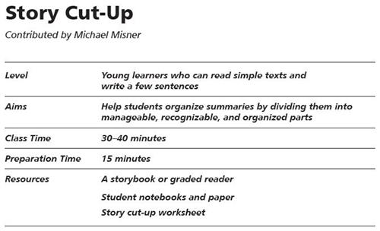
The following activities may be useful if you notice your students need some targeted support with their writing skills. Try these activities from the New Ways Series and the TESOL Resource Center (TRC).
Click the images below to view the full activity.
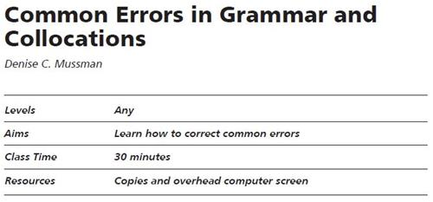

Establish a Culture of Shared Responsibility
Special Education Directors and Gifted and Talented Program Directors
- When evaluating special educators or teachers working in gifted and talented programs, give feedback about how well they are adapting their curriculum and instruction for identified English learners of diverse cultural backgrounds and varied proficiency levels.
Reading Specialists and Instructional Coaches
- If you are an instructional coach, revisit the methods and materials that all teachers use to determine whether any changes are needed to respond well to new populations’ language and literacy levels.
District Curriculum Directors
- Periodically revisit existing curricula to ensure their responsiveness to current English learners, particularly if backgrounds or learning needs change. For example, if students arrive speaking languages new to the district, find materials in these home languages for the curricular units mandated by the district and make them available to students.

MONITOR AND ASSESS STUDENT
LANGUAGE DEVELOPMENT

Language learners learn at different rates, so teachers regularly monitor and assess their language development in order to advance their learning efficiently. Teachers also gather data to measure student language growth.

Some Practices for Principle 5
Teachers monitor student errors.
By interacting frequently with our students, we can acquire a great deal of information about their progress. Some teachers record the results of their interactions (e.g., correct and incorrect uses of English) in an anecdotal way, use a check list, or change student grouping patterns and/or partners, depending on their newly developing proficiency.
Classroom Example: Teachers reteach when errors indicate that students misunderstood or learned the material incorrectly.
When errors are not part of the language development process, teachers plan for reteaching or additional practice. They may present a mini-lesson on the topic for the whole class or work with a small group of learners who need the support.
Teachers provide ongoing effective feedback strategically.
To be constructive, a teacher’s feedback in response to a learner’s error is delivered strategically and in a timely manner but it must also suit the age and language development level of the student. The feedback can be positive or corrective. It is important that the feedback be specific and related to what learners are doing well in addition to what they can improve.
Classroom Example: Teachers deliver feedback in a timely manner.
Students may be more able to use feedback if it is not delayed. Timeliness is more important with oral feedback than with written feedback. Private feedback is appreciated by all students, no matter their age.

Classroom Activities That Support Principle 5
Try these activities from books in the popular New Ways Series from TESOL Press!
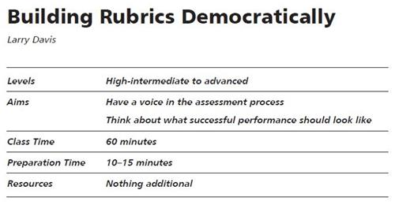
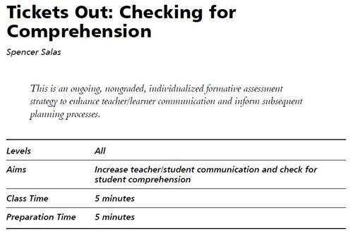
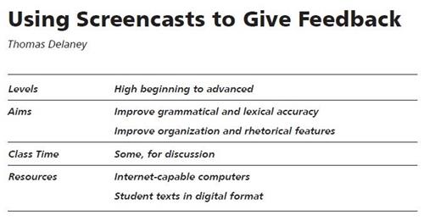
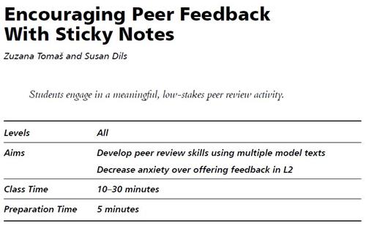
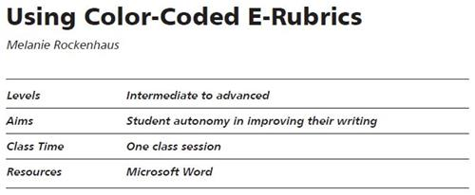
Try these activities from the TESOL Resource Center (TRC).
Incorporating Content and Language in Assessment
Using Formative Assessment in the Classroom to Monitor Student Learning

The activity below from Assessing English Learners in U.S. Schools (Farnsworth & Malone, 2014) offers a formative assessment that elementary teachers can use to determine student ability to retell texts.
Click the image below to view the full activity.
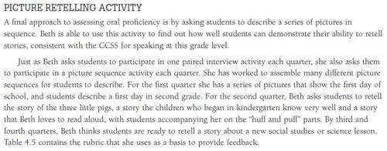

Establish a Culture of Shared Responsibility
Special Education Directors and Gifted and Talented Program Directors
- Ensure that all personnel involved in administering and interpreting assessments conducted to determine students’ eligibility for special education or gifted and talented programs are fully bilingual and bicultural. As needed, hire special education assessors who are bilingual, or, at a minimum, are trained to assess linguistically and culturally diverse students.​
Reading Specialists and Instructional Coaches
- Help incorporate test-like tasks in ongoing classroom assessments to familiarize students with test formats and tasks that they will encounter when taking district and state assessments.​
District Curriculum Directors
- Provide clear instructions about when assessments must be conducted in English and when they can be administered in students’ home languages. If unit assessments are to be conducted in English, specify the testing accommodations that should be used in the classroom and provided to students to make the assessments as fair and valid as possible.​

ENGAGE AND COLLABORATE
WITHIN A COMMUNITY OF PRACTICE
Teachers collaborate with others in the profession to provide the best support for their learners with respect to programming, instruction, and advocacy. They also continue their own professional learning.

Some Practices for Principle 6
Teachers collaborate with one another.
Exemplary teachers collaborate with others in the profession to provide the best possible support for their learners. They meet with colleagues to co-plan and share their expertise about second language acquisition as well as instructional techniques appropriate for students at different levels of proficiency.
Example: Teachers meet with colleagues regularly to co-plan for future learning.
ESL/ELD teachers need to become co-planners to ensure their students’ success in developing English language and content proficiency. These planning opportunities permit ESL/ELD teachers to become aware of the extent of the content learning required for students. They also allow ESL/ELD teachers to share information about students’ language proficiency with content teachers. The school administrators can help by making certain that scheduling allows teachers to collaborate with colleagues for planning.
Teachers are fully engaged in their profession.
Teachers participate in continuous learning and ongoing professional development and they also reflect critically on their own classroom practices. They develop leadership skills so they can be a resource in their school and get involved in designing programs and developing curricula.
Example: Become more engaged in your profession.
- Participate in continuous learning and ongoing professional development (check out TESOL’s professional development opportunities)
- Join a professional English teaching organization like TESOL International Association
- Attend local and global conferences, like the annual TESOL International Convention & English Language Expo
- Participate in online discussions (join the myTESOL Lounge, a free online community)
- Develop leadership skills (check out TESOL’s leadership programs) so you can be a resource at school and offer professional development workshops or act as a peer coach to a colleague.

Additional Roles for Teachers of English Learners
Professional Development Facilitator
Some methods of professional development are more formal, such as a series of full-day workshops, whereas others can occur informally, as when two teachers sit down and talk at lunch once a week. A combination of approaches may work best. Professional development suggestions follow:
- Presenting a workshop​
- Presenting a “technique of the month” at faculty meetings
- Participating in grade-level or departmental meetings
- Joining professional learning communities (PLCs)​
- Organizing “lunch and learn” sessions​
- Observing and coaching or mentoring individual teachers
- Modeling a lesson or technique for colleagues
- Inviting grade-level or content teachers to observe English language classes​
- Co-teaching and demonstrating techniques and debriefing afterwards​
- Establishing online communities for sharing ideas, techniques, and lesson plans

Participant on School and District Committees for Programming and Policy
Serve on leadership teams to ensure that English learners’ needs are considered in district and school improvement efforts. For example:
- Help design or refine academic programs for English learners as the population increases or student performance changes, such as a newcomer program for older arrivals with limited formal schooling or a new writing intervention course for long-term English learners. ​
- Encourage the establishment of an English learner tutoring center or an afterschool program in which students receive academic support. ​
- Advocate for a welcome center, where English learners can be assessed for services while families receive information about various district policies regarding student behavior, homework, school buses, community services, and so forth.

